The Cost Reimbursement Budget Template is provided to a Contractor to prepare a budget that will be included in the contract. All required information must be provided as documented in the instructions below.

STEP 1. Enter Contract Information

Enter the contract information, as shown in the example below.

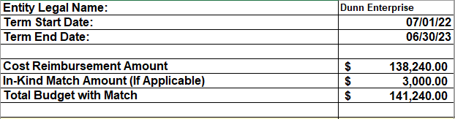

STEP 2. Enter Budget Information

Complete the Budget worksheet and include costs associated with delivering and/or supporting the contracted program, services and/or goods. This worksheet will be utilized by EHSD Fiscal and Program staff for contract/program monitoring, goods and services delivery, and invoice and expense verification purposes.

The Budget worksheet includes the following sections for entry.

Budget Category Description – Standardized budget categories for corresponding budget line items to be included. Any category not applicable to your budget may be left blank.

- PERSONNEL AND FRINGE BENEFITS
- OPERATING COSTS
- OTHER COSTS
- PARTICIPANT COSTS
- INDIRECT OVERHEAD AND/OR ADMINISTRATIVE COSTS

A brief description of each Budget Category is provided at the end of this document. You can click the above Budget Categories to easily access the description for each.

Budgeted Cost Reimbursement Amount – An estimated/budgeted dollar amount for each line item within the budget categories.

Budget Narrative – A narrative reflects how each budgeted line item amount is derived and includes brief mathematical explanations. Feel free to be as descriptive as needed.

In the Budget worksheet, enter line item descriptions, corresponding line item budget amounts, as supported in the Service Plan and/or described in the Payment Provisions portion of the contract, and the budget narrative of how those amounts were obtained, as referenced in the sample diagram below. There are formulas that will roll up the line item amounts within each Budget Category.

Lines (rows) can be hidden, unhidden, and inserted (added) to the budget template, as needed. Lines (rows) cannot be deleted at this time. Refer to the EXCEL Features section following Step 3.

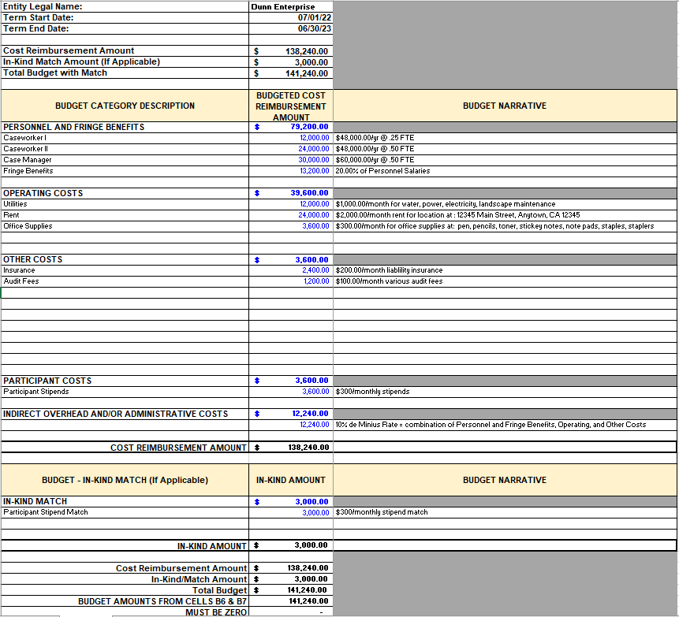

NOTE: At the bottom of the Budget worksheet, the row showing “MUST BE ZERO” needs to be zero before submission to your EHSD Program contact.

STEP 3. Submit to EHSD

Once the budget has been completed, submit to your EHSD Program contact.

EXCEL Features

Hide Line(s) (Row(s)) – Highlight the line(s) you want to hide, "right-click" and select Hide.
Unhide Line(s) (Row(s)) – Highlight the line(s) you want to unhide, "right-click" and select Unhide
Insert Line(s) (Row(s)) – To add an additional line(s) to a budget category, "right-click" and select Insert from the menu.

Budget Category Line Item Descriptions

PERSONNEL AND FRINGE BENEFITS
PERSONNEL – List each position by title of employee. Manually enter the annual salary, the percentage of time to be allocated to the project and cost.
For example, an Executive Director making $80,000 a year could allocate 60% (percentage of time) of her/his annual salary ($80,000), and budget $48,000. (Use decimals as the percentage of time, for example, 60.00 percent should be shown as 0.60).

Narratives are for brief mathematical explanations. Do not include service plan or payment provision descriptions in the narrative section.

FRINGE – EHSD recommends using prior year’s fringe costs incurred for staff who will be assigned to this contract when calculating a fringe benefit rate. Please factor in all data that may impact your fringe costs for the upcoming year, especially if the impact will increase your fringe costs.

OPERATING COSTS
General Costs to run a program. Some of these items may include the following: office supplies, space rental, facility maintenance, utilities, general facility related consumable materials and supplies, internet, and other costs related to supporting and maintaining organizational infrastructure.

OTHER COSTS
Other Costs - Costs that do not fit any of the categories should be included here.

PARTICIPANT COSTS
Costs directly related to the program are/or participation. Examples include: subsidized wages, supportive services (i.e. bus passes, day care costs, enrollment fees), participant payments (i.e. stipends, incentives), participant supplies (i.e. items/equipment consumable by participants or which become their personal property), tools or clothing related to employment or training, and participant tuition and fees incurred to achieve program objectives.

INDIRECT OVERHEAD AND/OR ADMINISTRATIVE COSTS
If you have an approved Negotiated Indirect Cost Rate Agreement (NICRA), please make sure to provide your NICRA when submitting your budget.

